**TABLE OF CONTENTS**

|  |  |  |
| --- | --- | --- |
| **NO** | **TITLE** | **PAGE** |
| 1 | Introduction | 1 |
| 2 | Objectives | 1 |
| 3 | Project Design   1. Sketch the screens with forms and controls needed 2. Properties for each object | 2 - 14 |
| 4 | Appendices   1. Interfaces Printscreen 2. Program Code 3. Database Tables Printscreen | 15 - 24 |

**INTRODUCTION**

The Students Information System is a software project developed to provide the information about students. The main purpose of this project is to store the student’s details and to find student information. The need is for a reliable database and flexible software systems to manage the complex and continually changing needs of management of students, course and the production of management information.

This is user friendly project that enables all kind of users to work with, even without any prior knowledge of computer.

**OBJECTIVES**

1. To store student’s details including personal information.
2. To develop a system that is user friendly project that enables all kind of user to work with.
3. To check student information which can be done faster by searching.
4. To change from manual system to computerized system.

**PROJECT DESIGN**

1. **Sketch the screens with forms and control needed**
2. frmSplash

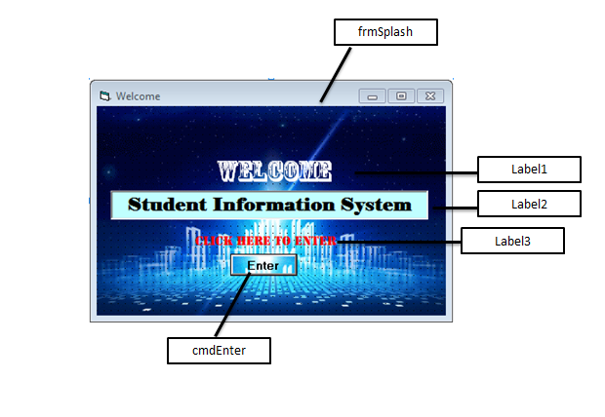

1. frmLogin

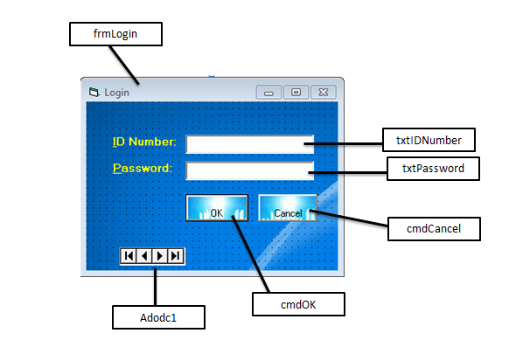

1. frmMenu

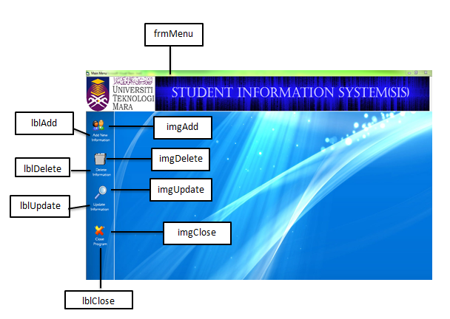

1. frmAdd

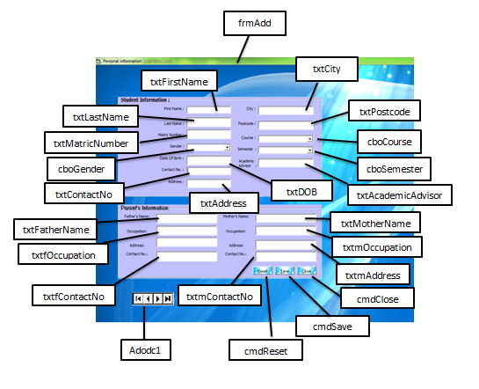

1. frmDelete

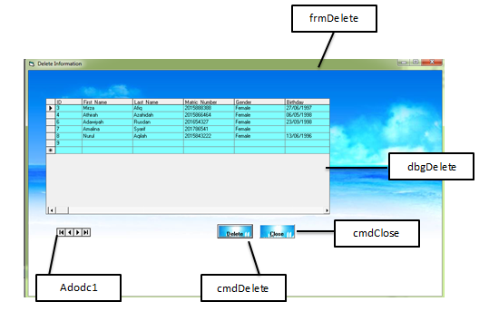

1. frmUpdate

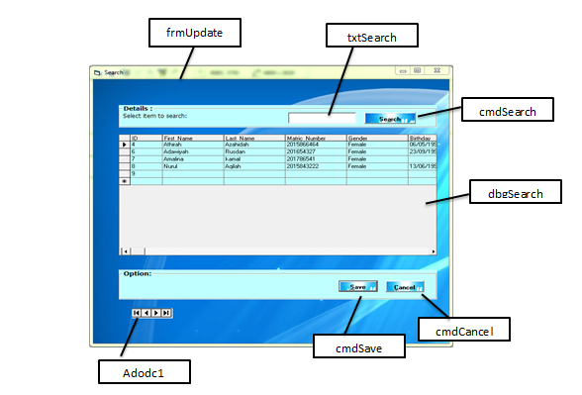

1. **Properties For Each Object**
2. frmSplash

|  |  |  |
| --- | --- | --- |
| **Object** | **Property** | **Setting** |
| frmSplash | Name | frmSplash |
| Caption | Welcome |
| WindowState | Normal |
| Label1 | Name | Label1 |
| Caption | WELCOME |
| Label2 | Name | Label2 |
| Caption | Student Information System |
| Label3 | Name | Label3 |
| Caption | Click Here To Enter |
| cmdEnter | Name | cmdEnter |
| Caption | Enter |

1. frmLogin

|  |  |  |
| --- | --- | --- |
| **Object** | **Property** | **Setting** |
| frmLogin | Name | frmLogin |
| Caption | Login |
| WindowState | Normal |
| Label1 | Name | Label1 |
| Caption | ID Number |
| Label2 | Name | Label2 |
| Caption | Password |
| txtIDNumber | Name | txtIDNumber |
| Text | (blank) |
| txtPassword | Name | txtPassword |
| Text | (blank) |
| cmdOK | Name | cmdOK |
| Caption | OK |
| cmdCancel | Name | cmdCancel |
| Caption | Cancel |
| Adodc1 | Name | Adodc1 |
|  | ConnectionString | (Select MS Jet OLE DB 4.0 and data file path) |
| CommandType | 1-adCmdText |
| RecordSource | Select * from tbUser |
| Visible | False |

1. frmMenu

|  |  |  |
| --- | --- | --- |
| **Object** | **Property** | **Setting** |
| Picture1 | Name | Picture1 |
| Image6 | Name | Image6 |
| imgAdd | Name | imgAdd |
| lblAdd | Name | lblAdd |
| Caption | Add New Student |
| Alignment | Center |
| imgDelete | Name | imgDelete |
| lblDelete | Name | lblDelete |
| Caption | Delete Information |
| Alignment | Center |
| imgUpdate | Name | imgUpdate |
| lblUpdate | Name | lblUpdate |
| Caption | Update Information |
| Alignment | Center |
| imgClose | Name | imgClose |
| lblClose | Name | lblClose |
| Caption | Close |
| Alignment | Center |

1. frmAdd

|  |  |  |
| --- | --- | --- |
| **Object** | **Property** | **Setting** |
| Frame2 | Name | Frame2 |
| Caption | Student Information: |
| Label3 | Name | Label3 |
| Caption | First Name: |
| txtFirstName | Name | txtFirstName |
| Text | (blank) |
| Label2 | Name | Label2 |
| Caption | Last Name: |
| txtLastName | Name | txtLastName |
| Text | (blank) |
| Label4 | Name | Label4 |
| Caption | Matric Number |
| txtMatricNumber | Name | txtMatricNumber |
| Text | (blank) |
| Label6 | Name | Label6 |
| Caption | Gender |
| cboGender | Name | cboGender |
| List | Male  Female |
| Style | 0 – Dropdown Combo |
| Label5 | Name | Label5 |
| Caption | Date Of Birth |
| txtDOB | Name | txtDOB |
| Text | (blank) |
| Label21 | Name | Label21 |
| Caption | Contact No.: |
| txtContactNo | Name | txtContactNo |
| Text | (blank) |
| Label15 | Name | Label15 |
| Caption | Address: |
| txtAddress | Name | txtAddress |
| Text | (blank) |
| Label7 | Name | Label7 |
| Caption | City: |
| txtCity | Name | txtCity |
| Text | (blank) |
| Label8 | Name | Label8 |
| Caption | Postcode |
| txtPostcode | Name | txtPostcode |
| Text | (blank) |
| Label9 | Name | Label9 |
| Caption | Course: |
| cboCourse | Name | cboCourse |
| List | CS110  EE111  HM113  BM112  EM120 |
| Style | 0 – Dropdown Combo |
| Label10 | Name | Label10 |
| Caption | Semester: |
| cboSemester | Name | cboSemester |
| List | 1  2  3  4  5 |
| Style | 0 – Dropdown Combo |
| Label1 | Name | Label1 |
| Caption | Academic Advisor: |
| txtAcademicAdvisor | Name | txtAcademicAdvisor |
| Text | (blank) |
| cmdSave | Name | cmdSave |
| Caption | &Save |
| cmdCancel | Name | cmdCancel |
| Caption | &Cancel |
| cmdReset | Name | cmdReset |
| Caption | &Reset |
| Frame1 | Name | Frame1 |
| Caption | Parent’s Information: |
| Label12 | Name | Label12 |
| Caption | Father’s Name |
| txtFatherName | Name | txtFatherName |
| Text | (blank) |
| Label14 | Name | Label14 |
| Caption | Occupation |
| txtOccupation | Name | txtOccupation |
| Text | (blank) |
| Label17 | Name | Label17 |
| Caption | Address: |
| txtfAddress | Name | txtfAddress |
| Text | (blank) |
| Label19 | Name | Label19 |
| Caption | Contact No.: |
| txtfContactNo | Name | txtfContactNo |
| Text | (blank) |
| Label13 | Name | Label13 |
| Caption | Mother’s Name: |
| txtMotherName | Name | txtMotherName |
| Text | (blank) |
| Label16 | Name | Label16 |
| Caption | Occupation: |
| txtmOccupation | Name | txtmOccupation |
| Text | (blank) |
| Label18 | Name | Label18 |
| Caption | Address: |
| txtmAddress | Name | txtmAddress |
| Text | (blank) |
| Label20 | Name | Label20 |
| Caption | Contact No.: |
| txtmContactNo | Name | txtmContactNo |
| Text | (blank) |
| cmdSave | Name | cmdSave |
| Caption | &Save |
| cmdClose | Name | cmdClose |
| Caption | &Close |
| Adodc1 | Name | Adodc1 |
| ConnectionString | (Select MS Jet OLE DB 4.0 and data file path) |
| CommandType | 2-adCmdTable |
| RecordSource | tbInfo |
| Visible | False |

1. frmDelete

|  |  |  |
| --- | --- | --- |
| **Object** | **Property** | **Setting** |
| frmDelete | Name | frmDelete |
| Caption | Delete Information |
| WindowState | Normal |
| dbgDelete | Name | dbgDelete |
| Adodc1 | Name | Adodc1 |
| ConnectionString | (Select MS Jet OLE DB 4.0 and data file path) |
| CommandType | 2-adCmdTable |
| RecordSource | tbInfo |
| Visible | False |
| cmdDelete | Name | cmdDelete |
| Caption | &Delete |
| cmdClose | Name | cmdClose |
| Caption | &Close |

1. frmUpdate

|  |  |  |
| --- | --- | --- |
| frmUpdate | Name | frmUpdate |
| Caption | Update Information |
| Frame3 | Name | Frame3 |
| Caption | Details: |
| Label1 | Name | Label1 |
| Caption | Insert first name or matric number to search: |
| txtSearch | Name | txtSearch |
| Text | (blank) |
| fraOption | Name | fraOption |
| Caption | Option: |
| cmdSearch | Name | cmdSearch |
| Caption | Se&arch |
| cmdSave | Name | cmdSave |
| Caption | &Save |
| cmdCancel | Name | cmdCancel |
| Caption | &Cancel |
| dbgSearch | Name | dbgSearch |
| Adodc1 | Name | Adodc1 |
| ConnectionString | (Select MS Jet OLE DB 4.0 and data file path) |
| CommandType | 1-adCmdText |
| RecordSource | Select * from tbInfo |
| Visible | False |

**APPENDICES**

1. **Interface Printscreen**

Splash screens used to the the user the program is loading and starting. User need to click Enter button to enter the system.

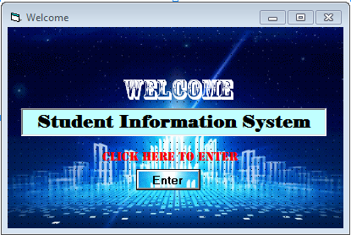

User need to login before using the sytem. If the login is success, the message box “Login Successful” will appear otherwise the warning message box “Login Failed,try again!” will appear.

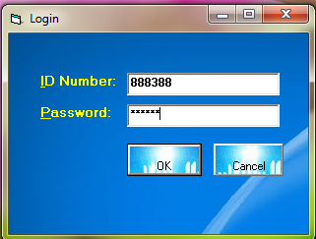

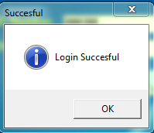 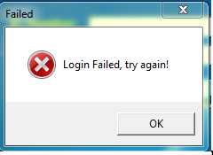

After login succeed, the user need to choose the menu to perform the action.

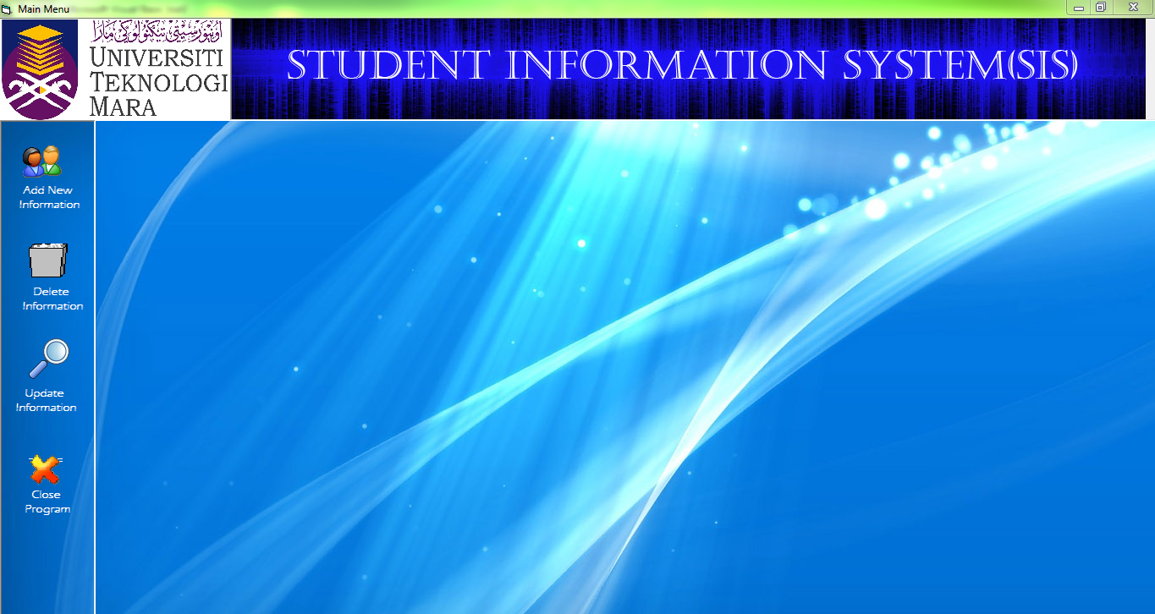

User need to reset the information first by clicking the reset button and key in the new information. Then, save it by clicking the save button. The data will be automatically save it in the database.

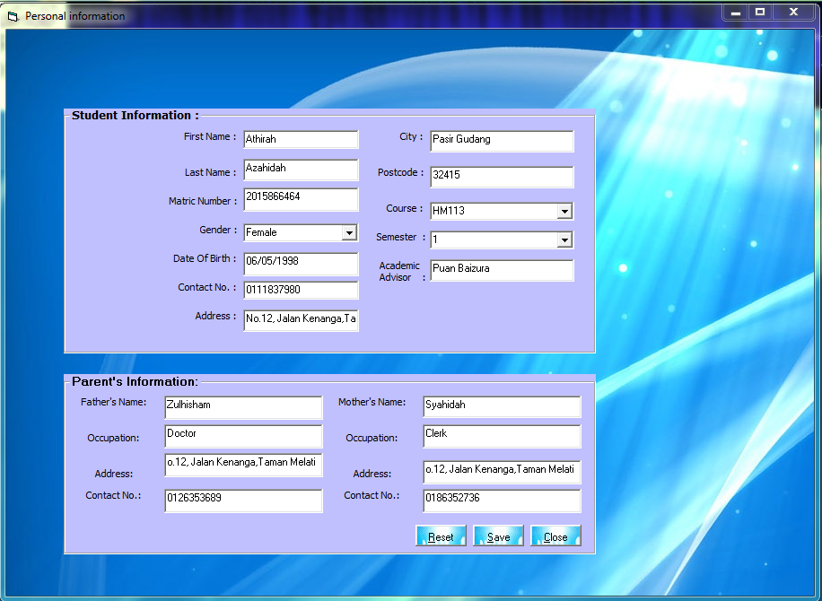

User need to choose the data that want to delete. After clicking the delete button, the warning message box “Are you sure want to delete all the information?” will appear. If user choose “Yes”, mesage box ”File successfully deleted” will be appear and the data will be deleted automatically in the database. If user choose “No”, the message box “Deleting cancel” will appear.

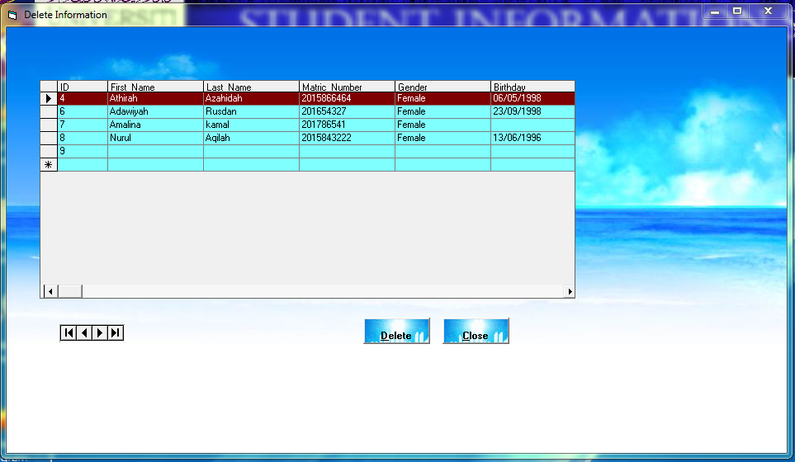

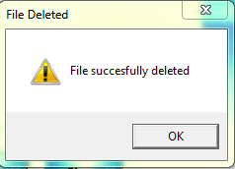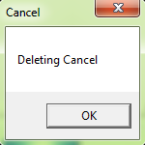

User need to search the data by entering first name or matric number and edit the data that want to edit . After clicking the save button, the data will be updated automatically in the database.

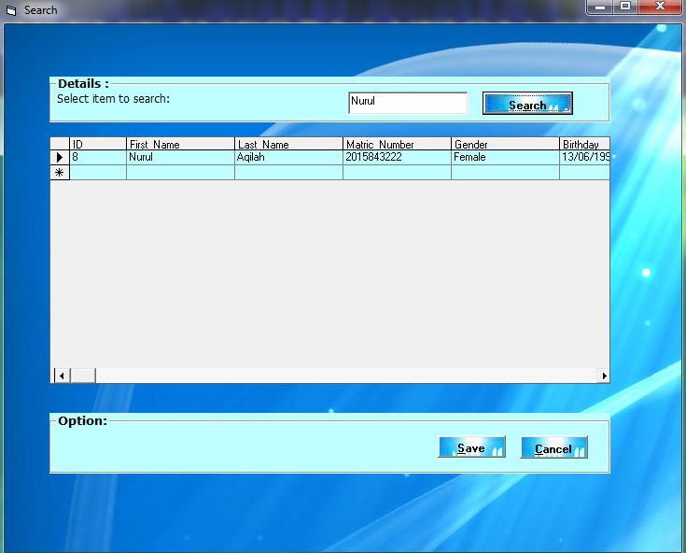

1. **Program Code**
2. frmSplash

Option Explicit

Private Sub cmdEnter_Click()

Unload Me

frmLogin.Show vbModal

End Sub

1. frmLogin

Private Sub cmdCancel_Click()

End

End Sub

Private Sub cmdOK_Click()

Adodc1.RecordSource = "select * from tbUser where ID_Number='" + txtIDNumber.Text + "' and Password='" + txtPassword.Text + "'"

Adodc1.Refresh

If Adodc1.Recordset.EOF Then

MsgBox "Login Failed, try again!", vbCritical, "Failed"

Else

MsgBox "Login Succesful", vbInformation, "Succesful"

frmMenu.Show vbModal

Unload Me

End If

End Sub

1. frmMenu

Option Explicit

Private Sub imgAdd_Click()

frmAdd.Show vbModal

End Sub

Private Sub imgDelete_Click()

frmDelete.Show vbModal

End Sub

Private Sub imgClose_Click()

End

End Sub

Private Sub imgUpdate_Click()

frmUpdate.Show vbModal

End Sub

Private Sub lblAdd_Click()

frmAdd.Show vbModal

End Sub

Private Sub lblClose_Click()

End

End Sub

Private Sub lblDelete_Click()

frmDelete.Show vbModal

End Sub

Private Sub lblUpdate_Click()

frmSearchUpdate.Show vbModal

End Sub

1. frmAdd

Option Explicit

Private Sub cmdCancel_Click()

Unload Me

End Sub

Private Sub cmdClose_Click()

Unload Me

End Sub

Private Sub cmdSave_Click()

Adodc1.Recordset.AddNew

End Sub

Private Sub cmdReset_Click()

txtFirstName.Text = ""

txtLastName.Text = ""

txtMatricNumber.Text = ""

txtDOB.Text = ""

txtContactNo.Text = ""

txtAddress.Text = ""

txtCity.Text = ""

txtPostcode.Text = ""

txtAcademicAdvisor.Text = ""

cboSemester.Text = ""

cboCourse.Text = ""

txtFatherName.Text = ""

txtfOccupation.Text = ""

txtfAddress.Text = ""

txtfContactNo.Text = ""

txtMotherName.Text = ""

txtmOccupation.Text = ""

txtmAddress.Text = ""

txtmContactNo.Text = ""

End Sub

1. frmDelete

Option Explicit

Dim strMsg As String

Private Sub cmdClose_Click()

Unload Me

End Sub

Private Sub cmdDelete_Click()

strMsg = MsgBox("Are you sure want to delete all the information?", vbYesNo, "Warning")

If strMsg = vbYes Then

Adodc1.Recordset.Delete

MsgBox "File succesfully deleted", vbExclamation, "File Deleted"

Else

MsgBox "Deleting Cancel", vbOKOnly, "Cancel"

End If

End Sub

1. frmUpdate

Option Explicit

Private Sub cmdCan_Click()

Unload Me

End Sub

Private Sub cmdSave_Click()

Adodc1.Recordset.Update

End Sub

Private Sub cmdSearch_Click()

Adodc1.RecordSource = "Select * from tbInfo where First_Name='" + txtSearch.Text + "' or Matric_Number='" + txtSearch.Text + "' or Course='" + txtSearch.Text + "'"

Adodc1.Refresh

If Adodc1.Recordset.EOF Then

MsgBox "Record Not Found,Enter any other Roll No or Name", vbCritical, "Message"

Else

Adodc1.Caption = Adodc1.RecordSource

End If

End Sub

1. **Database Tables Printscreen**

Table tbUser

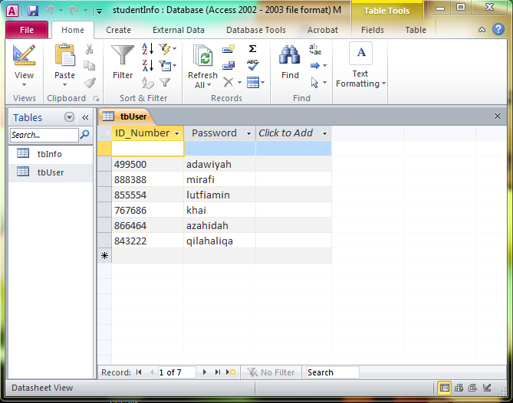

Table tbInfo

